3.13: Take +y to be upward.
Use the vertical motion to find the time in the air:
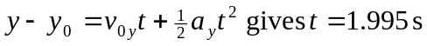
Then
b) 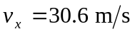 since 